CS223

Digital Design

Section: 1

Project Report

Name: Tolga Han Arslan

ID: 22003061

19.12.2022

b) RTL schematics for Ascending and Descending Sorting operations

c) Controller High-Level State Machine Diagram

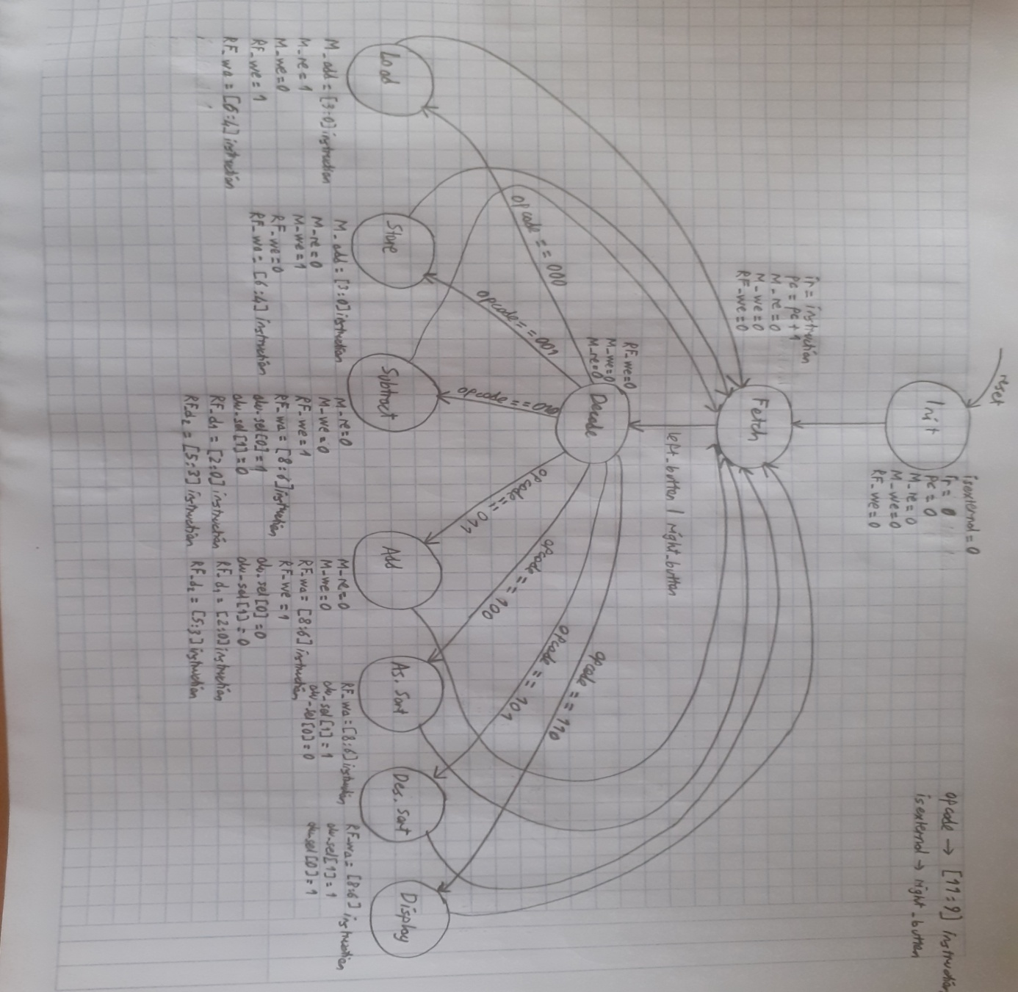

d) Controller Block Diagram

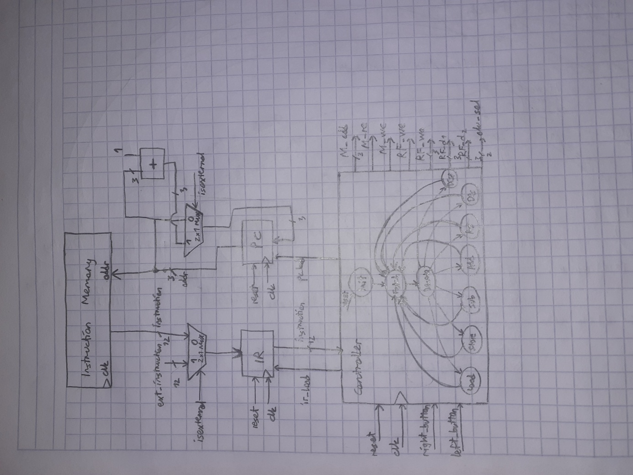

e) Controller/Datapath Top Module Block Diagram

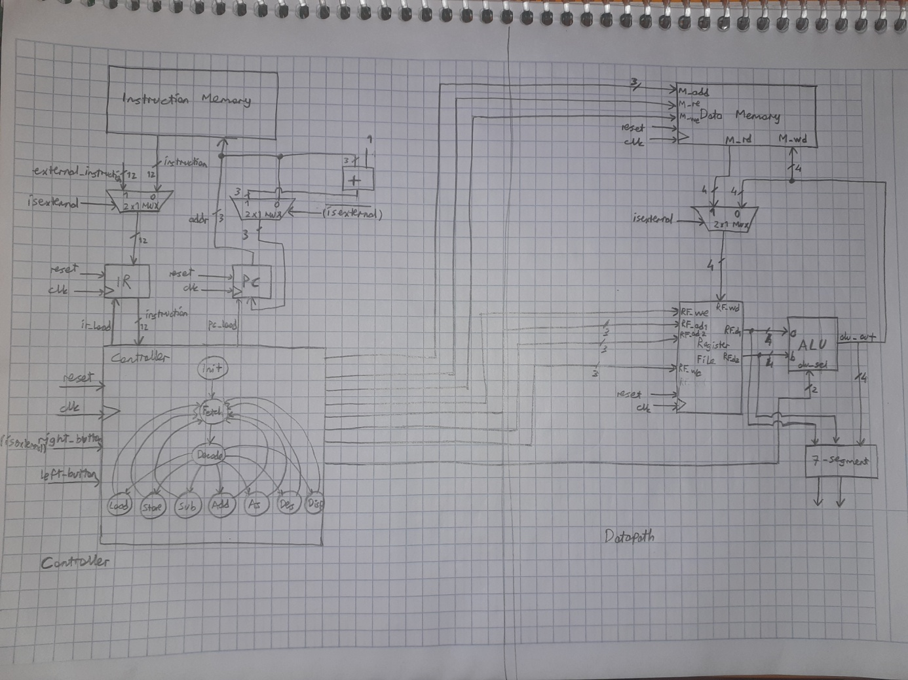

c) Testbenchs (This is optional, mainly for partial points if Basys3 doesn’t work properly)